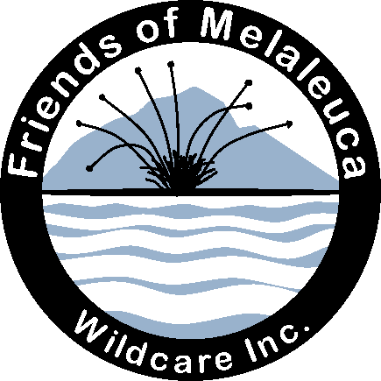

Wildcare Friends of Melaleuca
President's Annual Report (12 Sept 2019)
FoM currently has a membership of 122 (Wildcare webpage). We are fortunate to have an active membership comprising volunteers with diverse and useful skills.
Projects
Thanks to Wildcare for once again supporting our annual working bee in March with a grant of $2000 towards airfares and freight.
Roaring 40s Kayaking sponsored a facsimile of Win and Clyde Clayton's visitors book spanning the years 1950 to 1995. This is enjoyed by many yachting visitors to Claytons Corner. This year Roaring Forties kindly contributed sponsorship towards next stage of the heritage mining trail.
FoM was pleased to contribute to the PWS purchase of Ulrich aluminium scaffolding. This is housed at the PWS works depot and was extremely useful during the March working bee and certainly will be in future.
We are currently developing a formal Partnership Agreement with PWS in conjunction with our detailed Work spreadsheet and purchasing list.
During the year we produced a set of 6 greeting cards and associated poster and insert for card packs to promote the Deny King Heritage Museum. We set up the cards for sale in March with an honesty box in the Museum for the rest of the summer season, and had a folding and packing working bee on 22 June. Cards are now for sale on the Wildcare Website's shop, at Par Avion and at meetings and other functions. Thanks Erika for taking charge of card sales.
Meetings
FoM held three general meetings plus our AGM at DSS over the past year. Thank to Helen, Tony and Peter. In September we held our AGM, when the current committee was re-elected. After the general meeting Peter Marmion gave an entertaining talk about bushwalking in the 1970s. How times have changed!
At the May 2019 meeting we celebrated FoM's 10th birthday with a wonderful cake made by the Marmion clan, and a presentation by Janet and Geoff of our achievements over the decade. Then Peter Marmion showed some idyllic images of reflections on Bathurst Harbour at the end of the season. The speaker at the July meeting was Ian Johnston master mariner, co-founder of the Hobart Wooden Boat Festival and SW wanderer who delivered a lively and humorous presentation of magnificent photos of SW coastal scenery and anchorages. Many of the photos are featured in Ian’s recently published book The Shank, copies of which Ian has donated to the Deny King Heritage Museum and to Claytons. He also donated profits from sales of his book at this year’s Wooden Boat Festival to FoM.
Janet presented Ten Years of Wildcaring at Melaleuca for a Wildcare organised lunchtime talk to PWS on 15 August (about 30 attended). Janet and Geoff gave a presentation about the DKH Museum to The Dover History Group on Sunday 25 Aug, also well attended.
FoM meets with PWS both formally and informally and we appreciate the great relationship that we have with PWS staff Ian Marmion, Pip Gowen and Peter Rigozzi and Alan Thurston. We met with Ian on 21 November to plan 2019 working bee, and Geoff, Janet, Rob, Erika and Andrew met with Ian Marmion and Pip Gowen on 10 Sept to plan the March 2020 working bee and to work on the new formal Partnership Agreement with PWS.
Working bee
FoM’s annual working bee 13 -20 March 2019 was a great success, thanks to the energetic and skilled team. (See separate report). Freight on fishing boat Jean Nichols arrived 9 March and those at Melaleuca unloaded over the next 2 days. Freight included the aluminium scaffolding jointly purchased by PWS and FoM. The team of 13 volunteers arrived by plane and boat for the working bee.
We achieved a number of significant jobs during the week:
Re-clad north and west walls of Willson's, and attached treated pine cover-planks to exterior walls of the museum. The new aluminium scaffolding was a great asset for these two jobs. Replaced roofing iron on the heritage smelter using iron donated by Banfields.
Maintenance at Claytons: replaced some stumps under the lounge room, attached slats on beds painted window frames and walls and removed rubbish. Thanks to Charles Wessing who took this away on Jean Nichols, thanks to Rob Banfield for leading the Claytons work and Andrew Boon as Coxwain.
At Melaleuca, the electrical team re-installed the Willsons' old wind generator (reconditioned by Chris) and worked on PWS Quarters marine radio set-up and battery system. At the museum, installed a new display, being an aircraft propeller dating from an incident in 1948, and worked on plans for the mining trail and bushwalking huts interpretation.
At Kings, began oiling 1930s heritage First Camp, finished the sidewall restitution job on the house, re-built failing downstream jetty section of boat shed and replaced eroded wind-vane with one donated by BoM from their surplus store.
Repaired the attachment for the heritage windsock on south-western side of the airstrip. Carried out routine brush-cutting, fish-oiling and weeding. Planning commenced for future work including the mining trail and refreshing the interiors of bushwalkers huts.
All volunteers worked hard and enjoyed the camaraderie. Thanks everyone. Thanks Barbara for hosting volunteers in her home and Andrew Boon and Chas Wessing for freight and transport.
Reporting
Thanks to Erika Shankley for the group's Facebook page. I wrote a detailed report on the working bee for PWS and Wildcare including recommendations to help with planning next year's work. We have published four stories on the Wildcare Website during the year.
------------------
We appreciate Wildcare's support in awarding us a grant for on-ground work, and for Wildcare's behind-the-scenes office and bookkeeping work. Many thanks Sharon, Kim and Alex. Thanks Rob Banfield for organising the Claytons work this year. Thanks Ian Marmion, Peter Rigozzi, Alan Thurston, Pip Gowen, Justin Febey and Brett Knowles at PWS for their interest and support for our projects. And thanks to volunteers who helped at the working bee and at other tasks during the year. There is more on-ground work, and there are further projects to look forward to.
Janet Fenton, President, Wildcare Friends of Melaleuca, Sep 2019

