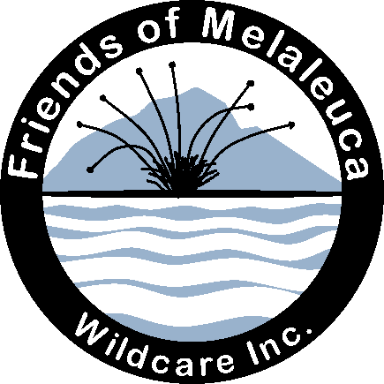

Wildcare Friends of Melaleuca
President's Annual Report (8 Oct 2020)
FoM currently has a membership of 162 (Wildcare webpage). We are fortunate to have an active membership comprising volunteers with diverse and useful skills.
Projects
Thanks to Wildcare for once again supporting our annual working bee last March with a grant of $2000 towards airfares and freight. A very successful week. Before the working bee we had several meetings negotiating a formal Partnership Agreement with PWS to use in conjunction with our detailed Work spreadsheet and purchasing list. The world was changing rapidly about the time of our working bee we listened to the news with our jaws dropping. We emerged from Melaleuca to a world of Covid Safe priorities.
In October 2019 I sent a proposal to PWS for our Mining Trail project. Ranger in Charge Ian Marmion has completed the necessary RAA for this, and the proposal is now with another level in PWS going through the approval process.
Sponsored projects:
Roaring 40s Kayaking gave sponsorship for the Mining trail last year; however as that is still in the approval process, Jenny and Reg have agreed that the money can be spent on furniture for the museum. This year they sponsored a picnic table for Claytons. Dave Ross rashly offered to build it, and this he did beautifully, with many finishing coats applied by Kim. Thanks to you both. The table is now disassembled and lying in wait in our car-port for a freighting opportunity to Melaleuca. Roaring Forties sponsorship is such a help and very much appreciated.
Melaleuca bushwalkers huts interpretation: This project was planned over the past two working bees. The content is now complete. We have had an amazing offer of sponsorship for the graphic design by Lea Walpole and sign fabrication by Red Arrow.
Working bee
FoM’s 12th working bee held between 11 -18 March 2020 was a great success, thanks to the energetic and skilled team. (See report in FILES on our webpage.) Freight via fishing boat Jean Nichols arrived on 10 March and the crew, caretakers and FoM already at Melaleuca had a busy day unloading, somewhat hampered by low tide. Volunteers arrived by boat (a big $ saving) and by air, a record of 20 this year including 8 new recruits.
We achieved a number of major jobs during the week:
Built a new tank-stand at Claytons for the twin tanks - Geoff and Rob put a lot of work into the proposal including estimating and drawing up a plan. Thanks to Rob for leading the construction as well as other painting and maintenance at Claytons. Thanks to Chris West, PWS Ranger, for the commuting to and from Claytons on PWS vessel Leptonyx as well as hands-on work. Other significant achievements: started roofing project on Kings house; refurbished the derrick at Willsons' landing; finished museum exterior paintwork, trim and gap-sealing; refurbished and added to museum displays; installed new tank-top for Second bushwalkers hut; serviced PWS and OBP bikes (thanks Ash Carr); installed LED lighting under PWS Quarters and a new inverter and extra solar panel. And thanks to Ian Johnston for the beautiful donation box he constructed and installed at Claytons.
Usual routine jobs completed: brush-cut fire-breaks; electrical test and tag; paint touch-ups (Second Hut and Red Shed, First Camp); fish-oil program; gravel paths; drains and weeds.
Thanks to Ian Marmion, Ranger-in Charge, for collaboration and guidance during the week as well as pre-panning sessions and the necessary RAAs. All volunteers worked hard and put in a combined 777 hours with enthusiasm and camaraderie. Thanks everyone. Thanks Barbara for hosting volunteers in her home and Andrew Boon, Bob Cleary, Ian Johnston and Chas Wessing for freight and transport.
Training
FoM funded three volunteers to complete the SRTA 'Work Safely at Heights' certificate this year.
Meetings
Last September we held our AGM, when the current committee was re-elected. After the September general meeting, Tony gave an entertaining talk about the 1910 Solar Eclipse expedition to Port Davey and Bruny Island.
On 19 October last year several FoM members attended Wildcare's first 'Wild and Open' gathering at the Sustainability Centre, Mt Nelson. Various group sessions discussed issues such as Wildcare's role in a landscape when PWS's direction has changed; funding and publicity; training - Wildcare's role.
Wildcare has set up regular Zoom chats with members and with branch leaders.
We finished the March working bee with a planning meeting for next year's work, but because of Covid restrictions during this year, we have had no general meetings until now. FoM usually meets with PWS both formally and informally. So far this year we have had an informal meeting with Ian and several phone conversations but no face-to-face planning meetings. We met with PWS on 10 Sept 2019 to plan the March 2020 working bee and to work on the new formal Partnership Agreement with PWS.
Reporting
Thanks to Erika Shankley for the group's Facebook page. Pip Jones wrote a delightful working bee report for the Wildcare news page. I wrote a detailed report on the working bee for PWS and Wildcare including recommendations to help with planning next year's work. We have published five stories on the Wildcare Website during the year, from poetry and pictures to participation—and a bit of history sleuthing.
------------------
We appreciate Wildcare's support in awarding us a grant for on-ground work, and for Wildcare's behind-the-scenes office and bookkeeping work. Many thanks Sharon, Kim and Alex. Thanks Rob Banfield for organising the Claytons work this year. Thanks to PWS staff, Ian Marmion, Peter Rigozzi, Chris West and Pip Gowen for their collaboration, interest and support for our projects. And thanks to volunteers who helped at the working bee and at other tasks during the year.
Janet Fenton, President, Wildcare Friends of Melaleuca, October 2020

