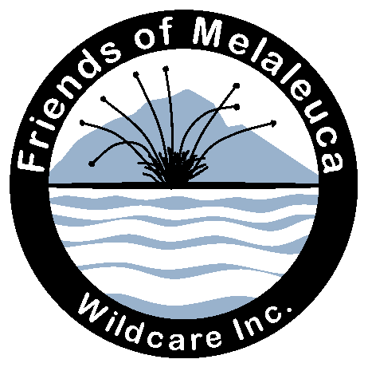

Wildcare Friends of Melaleuca
Working bee detailed report 2020

Wildare Friends of Melaleuca is working with PWS to maintain and interpret cultural heritage and to care for natural heritage at Melaleuca and Claytons Corner. Our branch was formed in 2009.
FoM carries out annual working bees each March, holds meetings during the year and has established and manages a small museum at Melaleuca. Chief challenges faced in this location are presented by the west coast weather, and the relative isolation. Transport and freight by air or sea are major costs and always require rigorous forward planning and flexibility.

Working bee, March 2020
A Wildcare Board of Management grant enabled FoM to run our twelfth working bee at Melaleuca, from 11 ~ 18 March 2020. Work was carried out in collaboration with Ranger-in-Charge, Huonville-South West, Ian Marmion, and this year we were also pleased to welcome new ranger Chris West, who was able to work with our group for most of the working bee. Chris's driving of the PWS tractor and boat Leptonyx was invaluable to the success of the working bee.
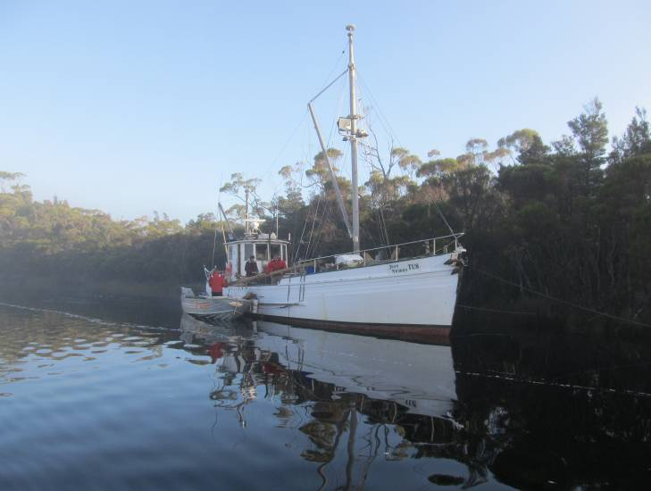
Unloading Jean Nichols, Photo: Janet Fenton
This year our particular projects were to build a new tank-stand at Claytons, complete the trim on the museum exterior, re-roof the heritage crusher shed, refurbish the Moth Creek derrick, install LED lighting in the PWS store and workshop under the Quarters, and replace some deteriorated roof sheets and lining at Kings’ house. Our routine annual brush-cutting, weeding, draining and fish-oiling programs continued. The weather held good for most of the week, but heavy rain all day on 13th restricted activities. This was an opportunity for a planning meeting. Together with a meeting on the last evening, these sessions were a productive time for discussion and sharing ideas.
Building material was transported to Melaleuca with the PWS re-supply aboard Charles Wessing's boat Jean Nichols, arriving on the 10th, just in time for the working bee. That was a busy day unloading for Janet and Geoff Fenton, PWS volunteer caretakers David and Di Masters and the Jean Nichols crew. Freight was distributed to relevant sites using the dinghies. Freight to the PWS Quarters was taken early by dingy via Dave Ross’s new navigation route across Melaleuca Lagoon before the tide dropped too low. Other equipment for our working-bee had been transported to Melaleuca previously by Janet and Geoff aboard Poinduk, and by Andrew Boon on Juliet and Bob Cleary on Georges Bay.
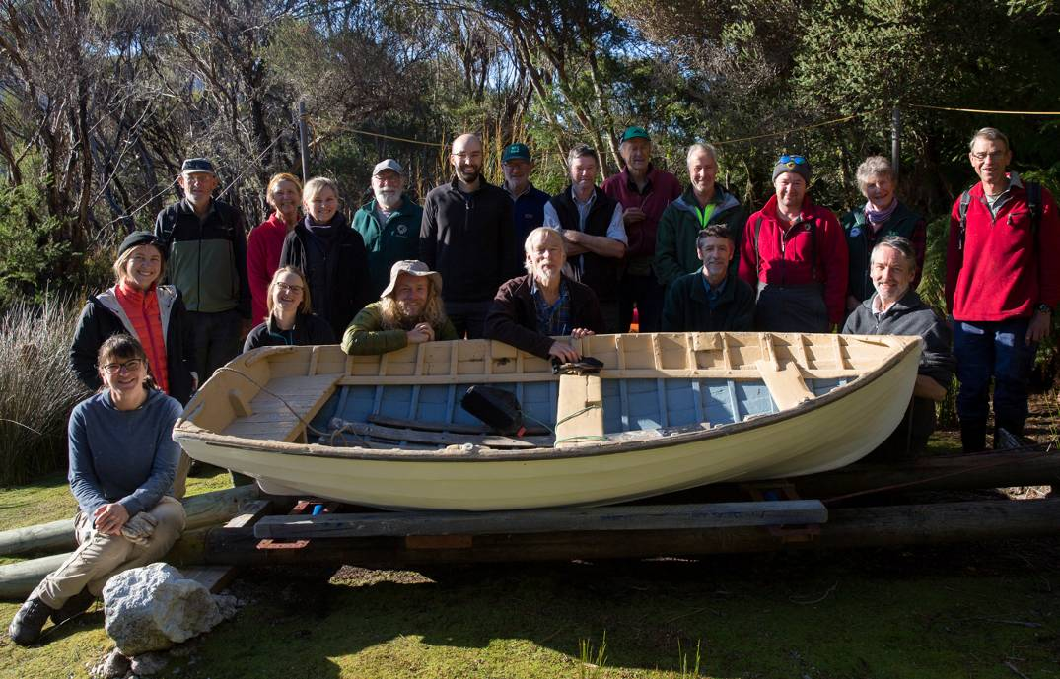
Volunteers and rangers, Melaleuca working bee 2020. Photo: Andy Johnson
We had a large group of volunteers this year. Of those selected, five had to withdraw, and their positions were soon filled by others. Selection was based on relevant skills which included qualified electrical engineers/electricians, coxswains, builder, construction white cards, professional rigger, engineer, mechanical skills, heritage interpretation, photography and a number of us held first aid certificates. Eight volunteers arrived by light aircraft on Wednesday 11 and twelve arrived by boat, making a big saving in air fares. Ranger Chris West arrived on 11th. Our group included eight new recruits. Volunteers were Andrew Boon (electrical work), Janet (team leader) and Geoff Fenton (workshop manager Kings), Chris Creese (works manager, Willsons), Rob Banfield (Claytons team leader), David Butler, David Mitchell, Rik Head, Andy Johnson (professional photographer), Pip Jones (brushcutter and chem. cert), Bob Cleary, Archie Donley (builder), Mel Jack, Georgie Carr, Ash Carr, David Ross (coxswain, rigger), Melissa Smith (museum), Ian Johnston and Hunter Birch. The flight did not arrive until late, leaving only a short time for introduction and safety briefings by Janet and Chris West, held at Kings'.
We much appreciate the input and direction from Ranger Ian Marmion who was able join us on Friday. Volunteers stayed in the bushwalkers hut, at Kings' and Willsons', and on board boats Juliet, Juliene and Georges Bay. We greatly appreciate Barbara Willson’s hospitality, accommodating four volunteers and hosting most of the evening meals as Kings’ house was a work site for most of the week. Thanks to Andrew and Bob who freighted equipment to Melaleuca and Bob who took a large load of rubbish away aboard Georges Bay.

Routine jobs
Brush-cutting is always an important part of our program. Pip Jones did a terrific job clearing the vegetation around the bushwalkers huts, firebreaks around the private leases, and mine sites. We had advertised for two volunteers and sharing this job between two would be far preferable as it is relentless heavy work.
Fish-oiling program. In this environment rust is an ever-present problem. Mel Jack, with help from Hunter Birch and Melissa Smith continued with the fish-oiling program and Mel drew a mud map showing the sites of standing machinery included in the program.
Draining: David Butler turned his attention to drains on the rainy day, concentrating on drains near the Willsons and along the roadway near the museum.
Weeding: Reduced clump of Watsonia, pulled rhododendron seedlings and cleared encroaching vegetation at Claytons garden area and around paths and drains. Pulled foxgloves at Kings'.
Paths and tracks. It was a great advantage to have Ranger Chris West driving the PWS tractor to load the Kings’ trailer with gravel enabling volunteers to re-gravel the roadway to the museum. Two trailer loads made a huge improvement on the museum road. Much shoveling and rock breaking ensued, including mashing rocks on the path to the toilets. The sledge-hammer handle was not up to Mitch’s enthusiasm and he had to fit a new one, thus demonstrating both brawn and skill.
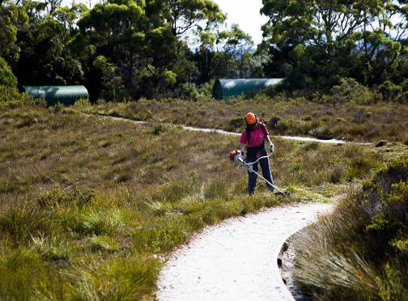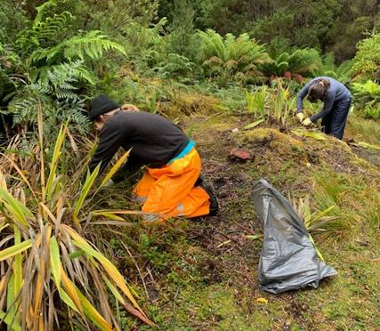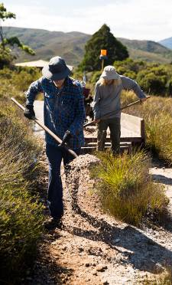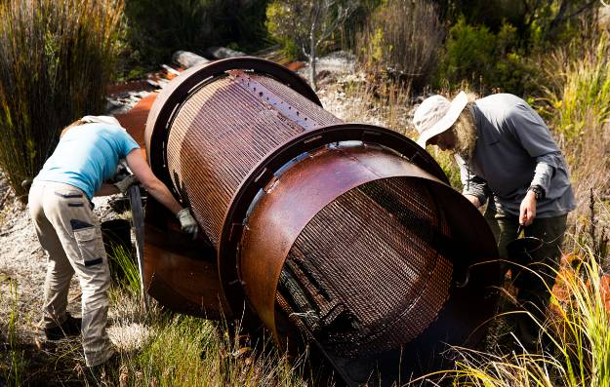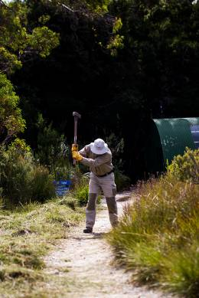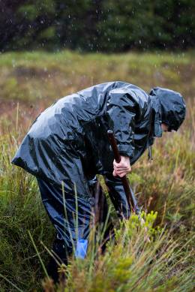
Routine maintenance jobs. Photos: Andy Johnson and Rob Banfield

Electrical projects
Andrew and the Juliet crew installed LED lighting under the PWS Quarters. Lights in the store and workshop make life a lot easier, especially when hunting for equipment. The team installed a new 12V dc/240V ac inverter in the Quarters and added an extra 100w solar panel to the Quarters solar power supply.
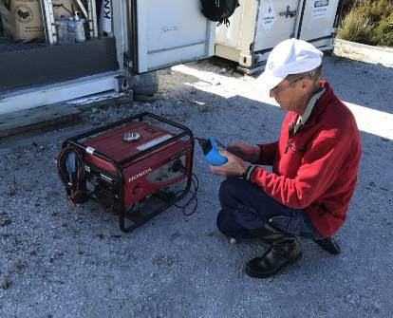
Testing and tagging
Photo: Rik Head
Andrew and team tested and tagged all 240v equipment in PWS Quarters, airstrip tool container, and OBP equipment in the Tractor Shed. They also tested and tagged electrical appliances and leads (including the overhead cable) at Willsons’; measured length of the catenaries and tower guys for future replacement with stainless steel; and with Chris they tested the spare wind generator.

Museum exterior
The Deny King Heritage Museum is located between the airstrip and the Kings’ crown lease. The building belongs to PWS and a MOU for its use by FoM as a museum was signed back in 2014.
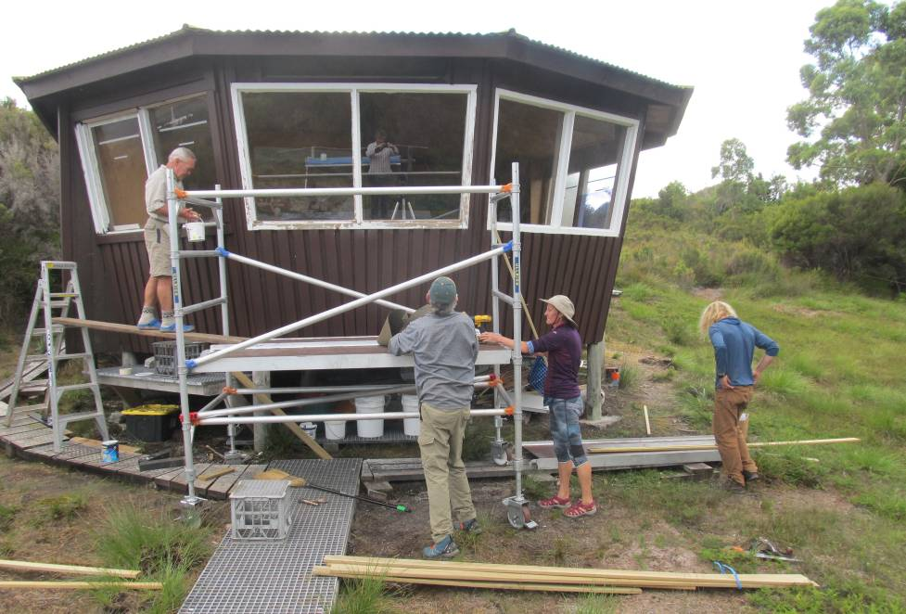
Working on museum cladding improvements, DKH Museum. Photo: Janet Fenton
Cladding on the exterior of the building was refurbished last working bee in a major effort. This year Ian Johnston led a team who finished off the trim, filled knot holes and gaps, painted second coat on cladding (mission brown) and painted exterior trim white. The scaffolding purchased last season was placed on site prior to the working bee and was usefully deployed again this year. A group of three bushwalkers, including professional house painter Ray Glancy was enlisted to help with the paint work. At the end of the week the scaffold was packed up and stored in the PWS Tractor Shed.

Mine sites
At the Rallinga mine site, Chris and Georgie re-roofed the heritage crusher shed using the second-hand brown Colorbond donated by Rob and Leanne Banfield that had been shipped to Melaleuca aboard Ballbreaker in 2018.
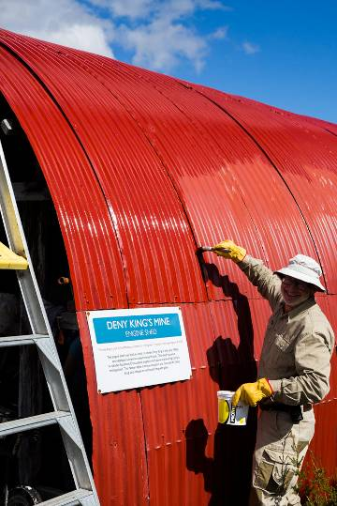
Mitch painting the Red Shed.
Photo: Andy Johnson
Some rust had shown through the paint on the NW shoulder of the on the Engine Shed (Red Shed). Mitch and others painted 2/3 of the roof using Wattyl Killrust ‘Delicious Red’.
A proposal was sent to PWS in September 2019 outlining a potential heritage mining trail to interpret significant existing relics for the many interested visitors. Janet took Melissa on a familiarisation walk around the route that has been planned over the past two years.

Bushwalkers huts
FoM has worked on the exterior of the two bushwalkers huts in previous working bees, including re-roofing one, painting both, and replacing guttering. This year, the interior of the CKM hut was cleaned. Andy, with help from Dave Masters, removed the deteriorated tank top from the Second hut tank. This was replaced with a new top supplied in two halves with pre-folded seam by Minehans in Kingston. Andy completed the seam and installed the new lid. Volunteers noticed that the floor in the CKM hut shook, so stumps should be inspected next year. Mitch touched up green paint on the Second bushwalkers hut where paint has been knocked off the roof with a rattle gun when lifting iron for gutter installation last year, and also touched up the end wall. Hunter made plywood billy stands. Rik assisted caretakers assemble a picnic table for the "village green".
During the previous working bee potential new interpretation for both bushwalkers huts was discussed, and in December 2019, Janet sent a proposal to PWS for FoM to develop and produce this.

Deny King Heritage Museum
Museum furniture was discussed. We would like to replace the shabby Par Avion camp chairs, the plastic folding table and square table, and consider a small couch for the reading area. Melissa is researching stool alternatives.
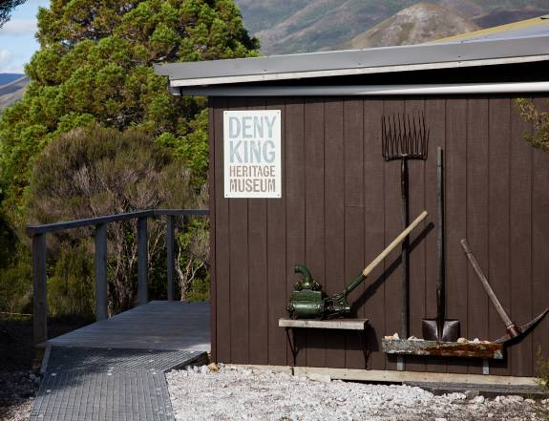
Deny King Heritage Museum.
Photo: Andy Johnson
There have been reports of bird strike on some of the windows. Paul Black (DPIPWE) photographed a window, demonstrating reflected sky in the upper half. Melissa enquiring with Think Big in Launceston about window film and printing images on windows.
The pick and shovel display on the front wall was refurbished with the objects now standing proud of the wall so the rusting parts can be fish-oiled easily. Melissa and Mel relocated the de Havilland propeller display to the vertical wall nearby as the site above the window was very back-lit and the object went largely unnoticed. Melissa installed three branded tin bags below Charlie’s portrait.

Claytons
Work progressed at the historic Claytons homestead, where Win and Clyde Clayton lived from 1962-1976. A major job this year was to build a new tank stand. The team was led by Rob Banfied and transported to and fro by Ranger Chris West in Leptonyx.
Summary notes: The tank stand design by Geoff and Holly (PWS engineer) was excellent and provided an accurate building guide. It utilised available recycled materials and was able to be simplified due to the gravel base being shallower than expected from previous “soundings”. Chris West (PWS) was invaluable on site and the support by Bob, Hunter, Mel, Melissa, Pip and Andy was fantastic. By transferring water between the various tanks, minimal water was lost, and the project was finished with 1.5 hours to spare!
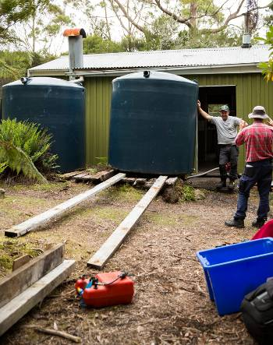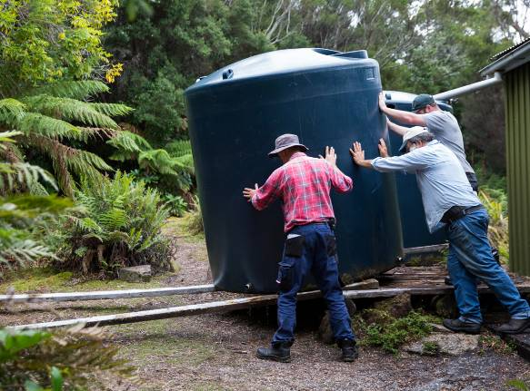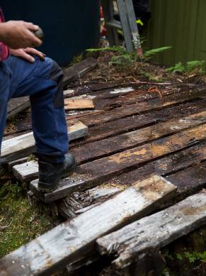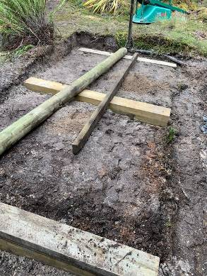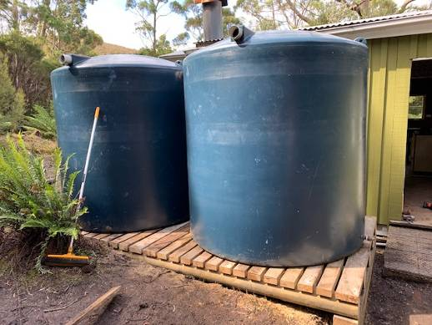
Replacing the tank stand. Photos: Andy Johnson and Rob Banfield

Garden weeding and tidy up, exterior handrail, and interior mold protection were other goals ticked off. Pip (chem. cert) dealt with the mold problem.
Tasks completed
- Tank stand renewed and water transferred
- Mold treatment on two-bedroom walls
- Stain applied to some new plywood wall panels
- Removed rhododendron seedlings, watsonia and encroaching teatree and ferns in main garden
- House cleaned up. Some items transferred to FoM store
- Useful firewood and stove firewood stacked in wood-tank
- Some rust conversion applied to steel fireplace flue
- Installed handrail and matching support strut on concrete path outside front door
- New bathplug fitted
- Filled in depression in ground near toilet at Parks request (OHS issue).
- General tidy-up of house surrounds
- Exterior white gloss paint, exterior green paint, and non-slip paint stored on bedroom shelves
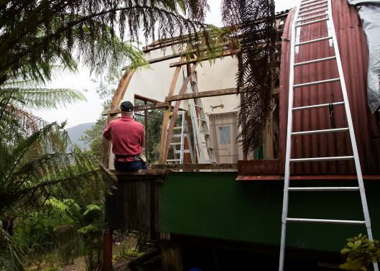
Replacing roof sheets, Kings
Photo: Andy Johnson

Private leases
Chris Creese was in charge of maintenance at Willsons and directed volunteers to jobs, tools and equipment. Chris cleaned the flue and carried out other maintenance on the house.
The First Camp at Kings' had been re-clad and partly oiled on previous working bees. The oiling job was completed this year.
At Kings' the main project of the past three years was stabilising the underfloor and side-wall structure of the whole house. This year the attention focused on the roof, which is leaking. Archie Donley, builder, David Butler and Geoff removed old curved sheets of galvanized roofing, fitted new battens where required, replaced iron with 17 new curved galv sheets over the living room. Insulation blanket was installed and, with Mel's assistance, new plywood replaced the old lining ply that had deteriorated badly due to damp conditions. Like for like materials were chosen for heritage considerations and metal compatibility. This is just the pilot start of a big project to re-furbish the roof of Kings' house.
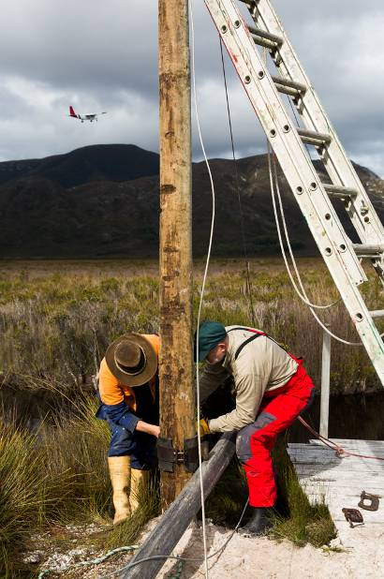
Work on the derrick
Photo: Andy Johnson
The derrick at Moth Creek was in need of refurbishment. Thanks to rigger Dave Ross it was all made sound this year. A treated pine pole replaced the old celery-top one. Dave brought in new ss rigging wire and fittings for the guys. All shackles were moused with seizing wire. The winch wire-rope was replaced and re-rigged as a single purchase hoist. Great job DR and team.

Sundry
This year we were fortunate to have Andy Johnson, a professional photographer, as a volunteer. He was kept very busy following work-in-progress at so many different sites, chasing the early morning light, and being involved with hands-on tasks as well.
Dave Ross, with caretaker Dave Masters, installed the gutter on the Troedel Shelter. The tide gauge at Melaleuca Lagoon/Inlet junction was removed, neatly re-painted by Melissa, and reinstalled. Pip checked the first aid kits and found that most items are now out of date. Ash Carr serviced all PWS and OBP bikes. Volunteers took turns as chef for the evening meals and produced some terrific feasts for the hungry hoards. Thanks to Chris for the annual Southern Cross heritage engine starting ceremony. It is an expectation that you can’t escape now, Chris!
Mel and Janet did the routine end-of-work stocktake of FoM equipment on Wednesday after most of the volunteers had departed on the morning flight.
Follow-up work: Ian Johnson made and installed a donation box at Claytons; caretakers bagged rubbish at PWS depot, and Bob Cleary transported it to Cygnet for collection by PWS. Melissa researched stools for the museum and posted a sample of window film.
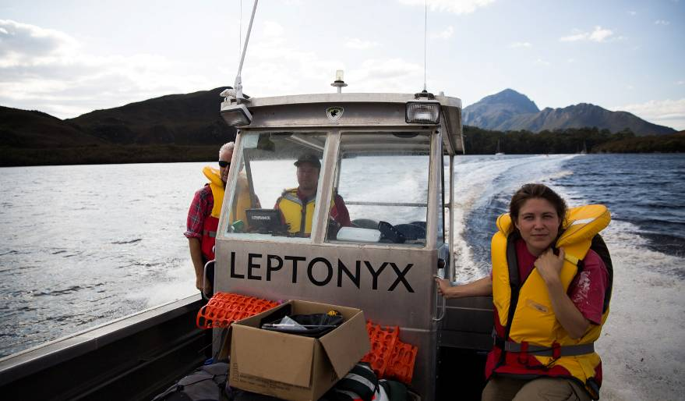
Chris West transported volunteers aboard Leptonyx. Photo: Andy Johnson

Special thanks to the enthusiastic and well-skilled team of volunteers who put in a combined 777 person-hours (excluding ranger's time) during this working bee week. The group spent an extra hour every evening reporting and planning. Many of the tasks recommended in last year's report have been completed. Recommendations were developed during wet day and evening discussions. As tight planning is essential for work on a remote site, many extra volunteer days were involved in planning, preparation, purchasing, loading and freighting materials beforehand, as well as assessing and reporting post working bee. (These hours are difficult to document and are not included here.)
Thanks to Wildcare for funding flights to Melaleuca for the working bee, and thanks to the volunteers for funding their own return fares. Thanks Andrew, Bob and Ian Johnston for transporting gear and passengers and to Barbara for hosting FoM volunteers in her home. We appreciate the great working relationship we have with Ian Marmion (PWS Ranger-in-Charge, Huon and SW) and his support and guidance during the planning stage as well as with on-site work, and to Pip Gowen (PWS Volunteer Facilitator), for her support and advice. The onsite practical work, boat transport and tractor driving by Chris West was invaluable.
Janet Fenton,
President, Wildcare Friends of Melaleuca, April 2020
Recommendations
Considerations for PWS and FoM to assist in planning.
Points are the result of discussions at the working bee, or carried over from last year.

- Approach Wildcare for training — Preferably Wildcare in general rather than specific groups as volunteers rove between branches and working bees. (Safe working at heights, brushcutting, chem cert.) SRTA provides nationally accredited training courses in Cambridge and Launceston, and will give reduced rates for volunteers. (Janet emailed Wildcare about this on 22 March.)
- Develop a folder for Maintenance Schedule with sections for projects. Include routines for things such as checking cable-ties on exterior wiring as these need to be replaced every 3 years (Barbara's replaced in 2018). Check and update at each working bee
- First aid kits. Pip checked and much of contents is out of date. Replace completely or have serviced? (Lynn, Accidental Health and Safety, for servicing. J&G bring out first aid kits after next visit to Melaleuca.)
- Deny King Heritage Museum
•Organise and install a more imaginative donation box. Accompany this with a card or pamphlet with QR code and website for direct donations through Wildcare FoM portal.
•Replace cardboard tin-returns with new ones printed on paper
•Create more information folders
•Update catalogue
•Furniture - stools, couch and new table with image such as 1922 nautical chart printed on surface
•Re-do 'please wipe feet' sign with current style mentioning sand, not just mud
•Survey (using GIS, historic photos and portions of corduroy above surface) the exact location and extent of the historic emergency runway. Ascertain whether portion of this can be revealed for future interpretation
- Mining Trail
•Follow up the proposal sent to PWS in Sept 2019
•Map sites, develop text and select images for laminated brochure
•Work out path sections and viewing posts
•Clear vegetation around objects on trail
- Claytons
•Finish painting and rust treatment on chimney. High temp spray paint is in FoM boxes
•Replace or stabilize, stain and clear seal ALL internal walls. 16L satin water based Estapol, using cutting brushes and 100 mm rollers, two coats per wall. Job requires 3 people and PPE.
•Non slip paint on entry floor
•Paint south western barge board and 1½ fascia boards with white (need extension ladder)
•Assist PWS to Install surplus “Gough” single toilet from Parks Melaleuca depot OR facilitate new toilet via Parks. (Top priority! the current long-drop, is a health risk.)
•Make a warning sign to hang near lounge room fireplace re fire hazards and care.
•Print notice for the new donation box
•Consider decorative use of heritage pressed iron garden shed shingles and conserve where necessary (recommend indoors in laundry/porch area…talk with Melissa)
•Carefully relocate two sheets of window glass to Melaleuca – they are at risk of breaking
•Relocate excess mortar mix bags to Melaleuca .
•Relocate surplus treated pine to Melaleuca PWS works depot
•Install brass or heavy-duty plastic fly wire mesh in all 3 tank inlet strainers.
•Install time capsule (2020) under new tank stand.
•Fit an outside tap to the tank near the backdoor. This should be the type that you have to hold open, so that it cannot be left on accidentally.
•Install instruction signs on the stop taps of the small house tanks similar to big tank.
•Install signs to TV Hill, Clydes Hill, Mt Beatie and toilet.
•Decide on location of heritage concrete gully trap that was found underground near the tanks.
•Investigation of springing in lounge room floor, minimal underfloor crawl space!
•Relocate the 2m treated pine walkway section to replace the dodgy walk bridge on the creek near the bay, wire netting on top may be needed.
•Facilitate jetty repairs. All salvaged materials to be retained by FoM.
•Asbestos pipe and others removal by PWS from under house and in the ground.
•Install ss bolts to the legs of the two single beds so that they are fixed and do not fold up dangerously when moved. Geoff measured for bolts.
•Heavy outdoor picnic table with seat for guests, perhaps near the back entry, or on tank-stand fill? Bob Cleary suggested heavy celery-top pine table and seats. Oil each year with Lanotec or decking oil. Send proposal to PWS.
•Create an information folder about FoM and work achieved at Claytons over past working bees.
- Works depot
•Install a new sign "PWS Works Depot" as there has been considerable confusion (Ian is dealing with this and other necessary signage).
•Assist PWS to build a simple 3-sided shed beside Tractor Shed for storage of grader blade, ripper, carry-all, forks, concrete mixer, scaffold, tools and trailer. These items are either outside and deteriorating in this difficult climate, or crammed inconveniently the shed with the tractor. A shed will prolong the otherwise short life of these costly assets. To house the above items the shed-size was measured to be approx 13m long by 5m deep. Could be erected over the existing concrete pad (approx 4.5 x4.5m) from the previous shed, gravelling the rest of the floor. Concrete slab has cracks but would not need to be structural. All existing building materials that are on site (Rob has photos)..framing, roofing, wall cladding, gutters, down pipes, etc could be re-used so that these materials do not become rubbish. This fits with the traditional heritage "re-use" ethic of Melaleuca. A three-sided shed is convenient, light and sufficient for weather protection. An on site inspection to would be needed followed by a written proposal. Alternatively, PWS purchase and ship an off-the-shelf kit-form shed.
•Move surplus steel cabinet (in Red Shed) to tractor shed for PWS as grit-proof storage of tractor lubricants, filters, funnels and spares.
- Mine Sites
•Continue sorting through the metals at resting machinery depot/rubbish pile and recover heritage items including Peter's first jig.
•Continue routine fish-oil program and make map with images of objects to assist volunteers locate items on the program.
•Consider options to stabilise control hut at Rallinga Mine separating plant. Separate proposal to PWS. Describe method. Jack up structure to put two or three skid timbers under it, then winch it back about 2 or 3 metres in a south-westerly direction (may need some minor ground leveling). See Rob's photos. Then level and fix structure into place. Maybe small concrete cast on site pads and bolt structure to them. Two additional wire guys could be installed to stop any storms trying to take it back to where it was. Safe access by visitors could or should be our aim with suitable interp. including gluing the coffee cup down to the bench. Need a PWS on site visit and Rob suggests they pay all costs if FoM reps. are needed.
- Troedel Shelter
•Replace (and up-dated) location map that was on outside wall.(PWS)
•Paragraph and image of David Troedel where appropriate in the shelter.
•Replace damaged galv coated ¼ turn lever ball valve tap on tank to prevent tap from dripping.
•Cladding on NW wall needs replacing. (PWS, Alan Thurston)
- Clearing, drains and tracks
•Top-dress pathways with gravel using PWS loader and a trailer - ongoing maintenance
•Routine maintenance. Maintain drains and clear back vegetation
•Routine maintenance. Brushcut firebreaks (2 volunteers required)
•Prune bushes around museum, leaving sight-screen triangle between path and OBP table
•Remove high central strip on path between airstrip and museum. This would make the path easier for the larger groups of tourists and also for bikes. Job for PWS tractor, narrow bucket.
- PWS Quarters gutter
Cleaning gutter is unsafe especially in damp conditions when the roof is slippery. A different gutter-guard arrangement would help. A deck all around the building would make it easy to access the windows and gutters from a step-ladder and stabilize the building. Meanwhile design and install a permanent rope-attachment system fixed to that roof. (Mark Simpson/Ian Marmion)
- Bushwalkers huts
•Clean both huts thoroughly inside (Earth-choice dishwash liquid)
•Check stumps. Is floor wobbly?
•Use rust-converter on steel pipe beams, 2nd hut
•Paint ceiling in 2nd hut, water-based paint, preferably lighter than present which looks like a masonite finish. Two coats, use long-handled rollers, 10L paint?
•Check deterioration, ceiling in CKM hut. Peter Rigozzi suggests don't varnish at this stage. Mark Simpson suggests low VOC polyurethane, turps based
•Install laser light (above table?) as hut is rather dark. Or two time-activated LED lights , from a simple battery/solar cell, independent of PWS system.
•If interpretation project (proposal sent to PWS in December 2019) is approved by PWS, source stories and images and develop interpretation for both huts as per measurements and themes previously noted. (Janet, Cathie, Melissa, Ian)
•Chris Creese suggested returning the chimney to CKM hut (currently in Engine Shed) and putting fly-screen over fireplace. PWS not keen at this stage
•Screen door suggested for Second Hut. Heritage issue though?
•Replace damaged galv coated ¼ turn lever ball valve tap on tank
- Battery-power tools for PWS (already have DeWalt drill, batteries & charger, but need impact driver, angle grinder,... - Chris West?)
- Electrical, PWS Quarters
•Install expanded solar panel and converter system .
•Ongoing routine testing and tagging
•Battery vacuum cleaner (Dyson, or cheaper similar) for cleaning huts, quarters and museum, if Rangers Quarters electrical system is expanded and can deal with recharging.
- Marine infrastructure
•Joan Pt slipway at the Narrows does not reach water at low tides and could result in difficulty for solo-bushwalkers and damage to boats. Recommend that PWS extend it during summer when a high pressure system is forecast and low tides are likely.
•Andrew suggests 5 knot sign should be displayed at floating jetty in Melaleuca Creek (there is a spare one in tool container)
•MAST will fund marine infrastructure. Suggest maintenance on Kings jetty, replace piece by piece, repairs in keeping with current look.
•MAST funding. Claytons wharf. Piece by piece maintenance?
- Private leases
•Continue house restitution, Kings
•Re-stump corner of box-shed, Kings
•Underfloor ventilation, Willsons
•Repair Willson's trailer
•Replace catenaries and tower guys at Willsons' with stainless steel
------------------------
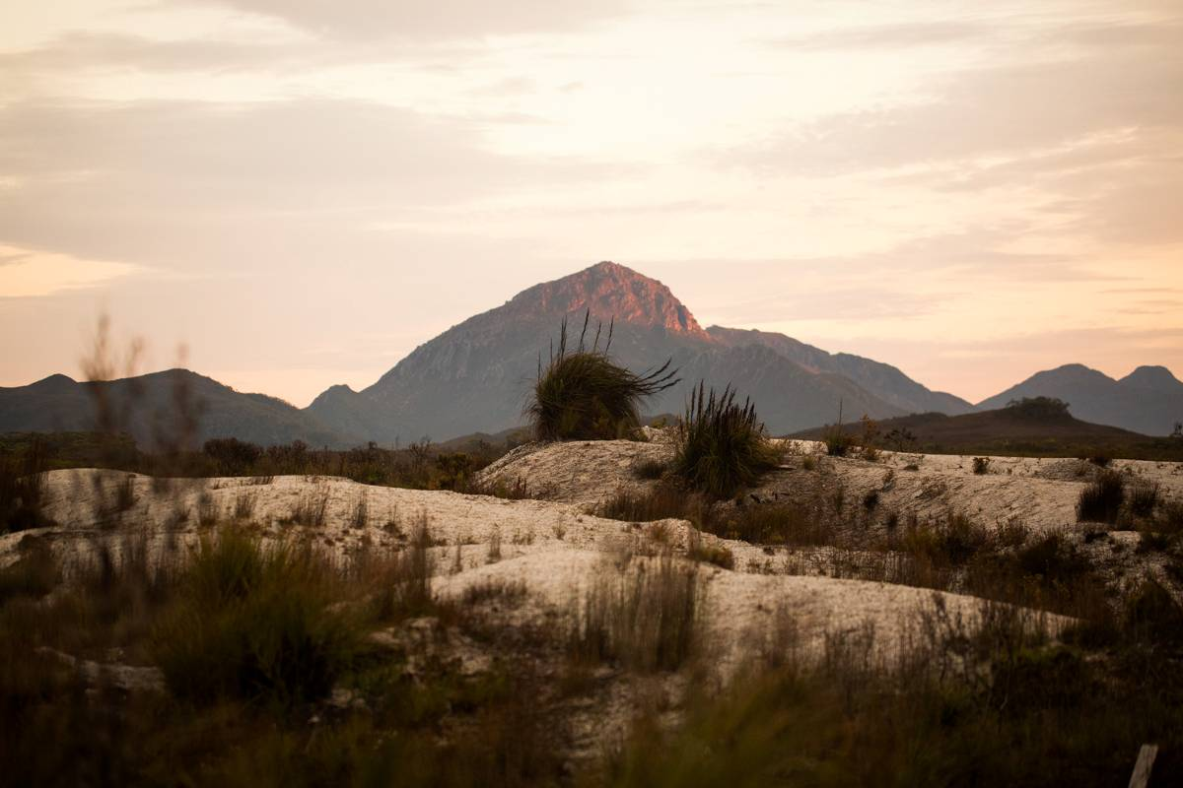
Photo: Andy Johnson

