Application and Information



Southwest National Park
Cockle Creek

Volunteer Caretaker Program 2017 18

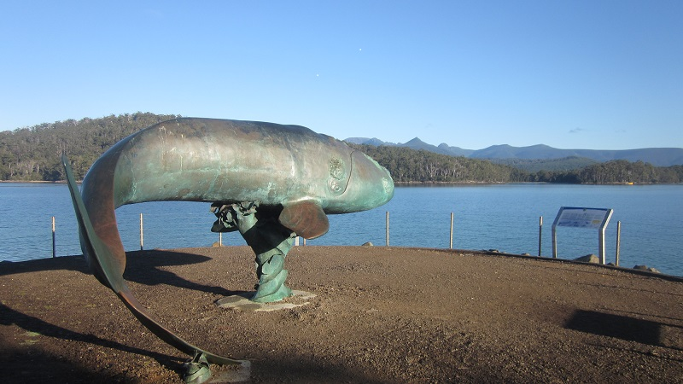

Whale Sculpture at Cockle Creek

CONTENTS

INTRODUCTION

ABOUT THE PROGRAM

VOLUNTEER TEAM

PROGRAM DATES

VOLUNTEER CARETAKER DUTIES

WHAT PARKS AND WILDLIFE SERVICE WILL PROVIDE

WHAT VOLUNTEERS ARE EXPECTED TO PROVIDE

ACCOMODATION

QUALIFICATIONS AND SELECTION CRITERIA

TRAINING

WORK HEALTH AND SAFETY

HOW TO GET INVOLVED

APPLICATION PROCESS

APPLICATION FORM

KEY DATES

CONTACT DETAILS FOR THE PROGRAM

INTRODUCTION

The Volunteer Caretaker Program in the Southwest National Park at Cockle Creek was established in 2004 when the Parks and Wildlife Service (PWS) recognised the need to provide the increasing number of visitors information about the area. The Volunteer Caretaker Program is an opportunity for volunteers to gain practical and visitor services experience at popular Nature recreation Area and National Park in the far south of the state.

Caretakers will essential be the ‘front face of PWS. They will meet and greet visitors to this popular site, which is also the gateway to and from the South Coast Track; provide visitor information services, carry out minor maintenance and assist Rangers as requested.

LOCATION

COCKLE CREEK

Cockle Creek is situated at the extreme southern end of accessible vehicular road south from Hobart, on the edge of the Southwest National Park and adjacent to the Recherche Bay Nature Recreation Area.

In the immediate vicinity of Cockle Creek there are facilities for vehicle based camping, boat launching and the start of popular bushwalking tracks to Fisher Point, South Cape Bay and the South Coast Track to Melaleuca.

Apart from the vehicle and tent, based campground, the area includes several private shacks (both leasehold and freehold), a Parks and Wildlife Service staff quarters.

The area is extremely busy over the summer months.

VOLUNTEER TEAM

A minimum of 2 adults

(Can be friends who know each other well and have confidence in being able to work effectively together for long periods of time, or couples)

DATES

For the 2017 18 summer, the program at Cockle Creek will begin
In early December 2017 and run through until end of April 2018

VOLUNTEER CARETAKER DUTIES

CARETAKERS WILL:

- Provide a visitor information service: welcome, meet and greet visitors
- Carry out regular servicing of boot wash station, walker’s registration booth
- Carry out minor maintenance as directed by the Ranger
- Monitor visitor numbers and impacts and conduct visitor surveys
- Provide communications with Hastings/Huonville Field Centre on day to day operations
- Act as first response and communication hub in the event of emergency
- Report issues such as excessive mess, offensive behaviour, safety hazards, and bushfire risk to PWS ranger staff
- Other tasks identified and appropriate to the capacity of individual Volunteer Caretakers

CARETAKERS WILL NOT be required to:

- Collect campground site fees (none are levied at Cockle Creek)
- Maintain campground toilets (apart from minor or emergency maintenance), or
- Be involved in any law enforcement activities, or confront visitors over any such issue unless there is an immediate risk to personal safety

PARKS WILL PROVIDE
The Parks and Wildlife Service will provide:

- Accommodation including beds, fully equipped kitchen facilities, and lighting (see below)
- Consumables i.e cleaning fluids, tea towels, sunscreen, alcohol rub for sanitising hands, gas,
fire wood
- Site Induction and safety briefing. Training in the role of Caretaker
- PWS staff roster in order to assist communication when support needed
- Works program where appropriate depending on the time of the season
- Emergency communications
- First aid kits
- Any tools and equipment necessary for minor maintenance duties
- Volunteer Caretaker Uniform (shirt, hat, jacket and name badge)
- BBQ and camp chairs/table
- Support in form of unscheduled visits to site / phone contact
- Assist / direction / instructions in the case of an emergency

VOLUNTEERS WILL BE EXPECTED TO PROVIDE:

- All food for the duration of their duty
- All bedding including pillows and Queen Bed or single bunk bed mattress protector covers
- Electric blanket, or hot water bottles if needed.
- All clothing apart from uniform items (see above) – for all weather
- Provide some old clothes for working in or overalls
- Some consumables e.g. toilet paper, clothes washing liquid, paper towels, matches,
- Transport to and from Cockle Creek
- Personal equipment and resources e.g. kayaks, laptop, cameras, etc.
ACCOMMODATION

COCKLE CREEK

Volunteer Caretakers will be accommodated in the PWS staff quarters at Cockle Creek. The building is a smallish two bedroom house with the following facilities:

- Well-appointed kitchen with all utensils, gas hot water and cooking and fridge
- One bedroom with double bed (other bedroom to remain free for casual staff visits)
- Bathroom with hot showers
- Solar electricity adequate for lighting and small appliances
- Telephone
- Small workshop and office
- Parking close to the quarters
- NO washing machine – hand washing tub only

Important Note: At Cockle Creek CT’s will not always have sole occupancy of staff quarters. Other staff or emergency services may need to use the facilities over the summer. Caretakers will have the use of the whole quarters unless staff require it. If that happens Volunteers will be asked to confine personal possessions to one bedroom and to share common facilities such as bathroom, kitchen and lounge.

Qualifications and Selection Criteria

Volunteer Caretakers will not require specialist or trade qualifications, but general knowledge of the area, communication and practical skills. If, however, you have specialist qualifications that you consider may be useful (e.g. teaching, interpretation, carpenter, electrician, weed management) please advise us on the program application form.

Volunteer Caretakers will be selected according to how well they meet the following selection criteria:

- Ability to live and work in a remote location, without easy access to shops or entertainment options, extended periods

- Ability to communicate well with a broad range of visitors expected at Cockle Creek
Be flexible and take direction from Rangers and Regional Volunteer Facilitator

- Knowledge – (General) in particular of the Southwest National Park, Southwest Conservation Area and Recherche Bay Nature Recreation Area. General knowledge of reserved land management

- Possessing a broad range of practical skills and fitness appropriate to general outdoor tasks at Cockle Creek

- First aid qualifications (St John Workplace 2 preferred minimum).

TRAINING
The Parks and Wildlife Service will conduct training, induction and familiarisation sessions on your arrival at Cockle Creek before starting your placement on site.

WORK HEALTH AND SAFETY
The provision of a safe working environment and safe working procedures is mandatory for all works carried out by PWS. The Volunteer Caretaker Program at Cockle Creek will be carried out according to all current safe-working guidelines. Volunteers will be made familiar with these procedures and will be expected to adhere to them.

HOW TO GET INVOLVED
If you are interested in taking part in the Cockle Creek Volunteer Caretaker Program this summer we ask you to complete the Application Form included with this information package.

Please be aware completion of the application form does not guarantee a place on the program.

APPLICATIONS
A minimum of 2 Adults required for this volunteer position
Individuals or couples

Email application to: pip.gowen@parks.tas.gov.au.

Applications Close on: Fri 22 September 2017

Applicants will be notified if they have been successful by Friday 29 September.

Pip Gowen
Regional Volunteer Facilitator (South)
Parks and Wildlife Service

August 2017

See Application Form below

Department of Environment
Parks, Heritage and the Arts

Cockle Creek
Volunteer Caretaker Program: Summer 2017 /18

Application Form

(Complete one form for each volunteer if applying individually or one form per couple if you are planning to work together on this program)

Contact Details

Name (Volunteer 1):_____________________________________________

Address________________________________________________________

________________________________________________________

Phone: Home _______________________
Work _______________________
Mobile ______________________

Email: _________________________________________________________

Age: _________________

WILDCARE 2017 Membership number: _______________________________

Name (Volunteer 2): ______________________________________________

Address: _________________________________________________________

_________________________________________________________

Phone: Home _______________________
Work _______________________
Mobile ______________________

Email: ___________________________________________________________

Age: ____________________________

WILDCARE 2017 membership number: ________________________________

Preferred Placement Dates (please order by number 1 -5 )

Indicate any months that you are NOTavailable

December

January

February

March

April

NOTES: ADD ANY INFORMATION USEFUL REGARDING YOUR PLANS

Addressing the Selection Criteria

- Provide a brief summary of your experience living and/or working in remote locations
Where there is little access to shops and entertainment.

- Provide evidence of your ability to communicate with the broad range of visitors
expected at Cockle Creek and Melaleuca

- Describe your experience that would give you confidence in your ability to be flexible, also to take direction/instructions from Rangers who are in charge of the site.

- Provide evidence of your knowledge, in particular if the Southwest National Park, Southwest Conservation Area and Recherche Bay Nature Recreation Area and of general principles of Reserved Land Management

- Describe any practical skills appropriate to general outdoor tasks at Cockle Creek and Melaleuca.

Selection Criteria Cont.
- First Aid Qualifications. Please Attach Copies

- Any other qualifications that might be useful at Cockle Creek , Interpretation, Education, Weed
Eradication, Brush Cutting, office work, front of house etc.

Signed 1. __________________________________ Date _________________

Signed 2 __________________________________ Date _________________

Forward all completed applications to:

Pip Gowen
Regional Volunteer Facilitator
Parks and Wildlife Service

E: pip.gowen@parks.tas.gov.au

By Friday 22 September 2017

Applicants will be notified if they have been successful by Friday 29 September 2017

The Parks and Wildlife Service gratefully acknowledges the
Support of
WILDCARE Incorporated Friends of Far South

In the delivery of the

Cockle Creek Volunteer Caretaker Program


