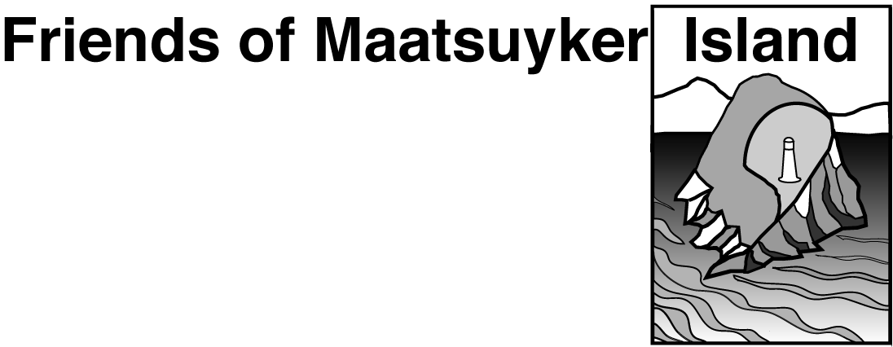

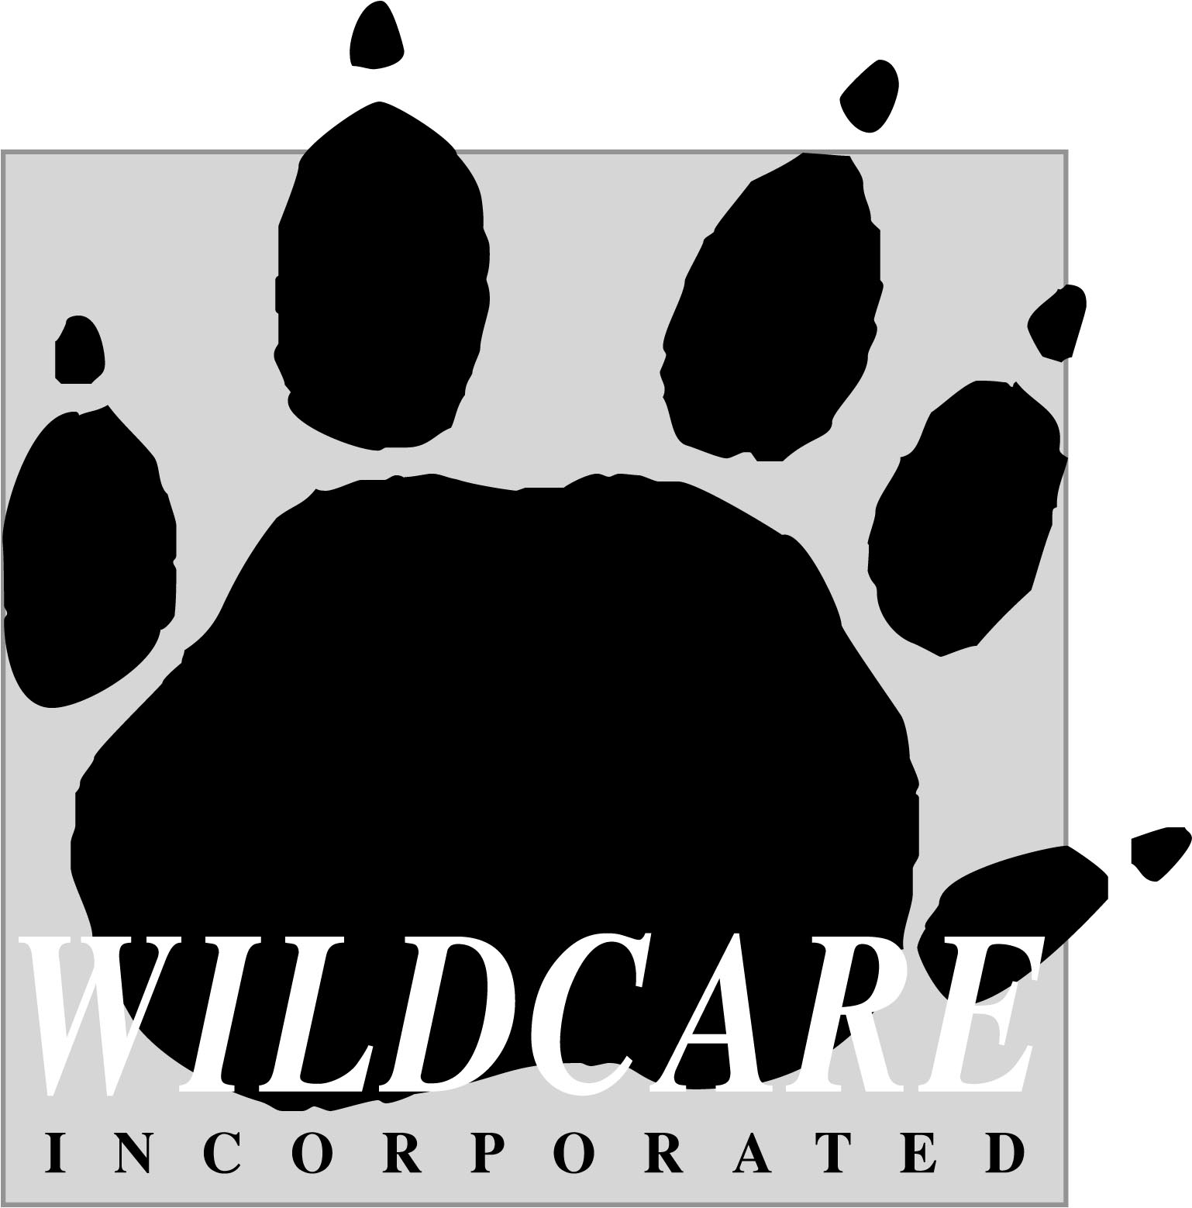

Maatsuyker Island
Feb/March 2019 on-island project work

Information for Applicants –
Weed Control/Shearwater Monitoring/Building Maintenance
Working Bee (Team of 10)

Introduction
This document (including Application Form at the end) provides information for prospective participants for the Friends of Maatsuyker Island - Wildcare Inc. (FOMI) and Parks and Wildlife Service (PWS) Working Bee on Maatsuyker Island in Feb/March 2019.
The Maatsuyker Island Weed Control, Shearwater Monitoring and Building Maintenance programs are a continuation of the partnership between FOMI and PWS. Different aspects of the project work are funded by Tasmanian Landcare Fund, Pennicott Foundation, Wildcare Inc. and FOMI general funds.
About Maatsuyker Island
Maatsuyker Island is approximately 180 ha and is located about 10 km off the remote south west coast of Tasmania. The island has a rugged, steep and rocky coastline and, apart from the areas cleared for the lightstation, is covered by dense, scrubby vegetation. It is a harsh environment and the weather can be cold, wet and windy.
A lighthouse tower, lightkeepers houses and outbuildings were built in 1891 and operated until 1996 when the original light was decommissioned and replaced with an automated beacon. Apart from the European heritage values of the lightstation, Maatsuyker Island has significant natural values, primarily as a habitat for breeding seabirds and seals, and is also a site of importance to the Tasmanian Aboriginal community.
The island is managed by the PWS as a part of the South West National Park and Tasmanian Wilderness World Heritage Area. A permanent presence is maintained on the island through the PWS volunteer caretaker program. FOMI works in partnership with PWS to care for the many values of the island.
About the Feb/March 2019 Working Bee

There are up to five spaces available to participate in the on-island Working Bee in Feb/March 2019.
Tuesday 26th February 2019: Depart for Maatsuyker Island
Friday 8th March 2019: Return from Maatsuyker Island
(NB: You will need to be flexible with your schedule either side of these dates to cover the possibility of weather delaying helicopters)
It is important to be aware that all times and plans are controlled by the weather. Delays can be expected at any point – both going out to Maatsuyker Island or returning to Hobart. Helicopter travel will not be undertaken in unsafe conditions and patience will be required if bad weather is experienced. Therefore, it is important not to plan important engagements for a few days following the planned return date or at least one day prior to the planned departure date.
FOMI Working Bee Coordinators
Marina Campbell: 0409 659202; bellegg@bigpond.net.au (Trip Co-leader & Weed Control Program)
Sheryl Hamilton: 0448 174298; sheryl.hamilton@Latitude42.com.au (Trip Co-leader & Shearwater Monitoring Program)
Amy Saunders: 0438 589803; amygracesaunders@gmail.com (Weed Control Program)
Ron Fehlberg: 0427 727382; ron.glenda@bigpond.com (Building Maintenance Program)

Works Program – Weed Control, Shearwater Monitoring and Building Maintenance
Weed Control program: We will undertake follow-up control and survey for Blackberry, Montbretia and Hebe elliptica. All sites will be revisited, monitored and, if necessary, treated by cut and paint herbicide application, hand pulling or digging.
Shearwater Monitoring program: You may be involved to assist for 1 or 2 days scribing data for the shearwater burrow occupancy monitoring project. At this time of year, we will be recording whether there is a short-tailed shearwater chick in each of the study burrows.
Building Maintenance program: You may be involved in the restoration of bedroom floors and assist with other maintenance tasks. Please let us know if you have any relevant building skills.

NB: Depending on your skill-set, you will need to be flexible to help where required and assist with any of the above projects. Tasks may also include assisting the Volunteer Caretakers as well as maintaining the historic haulage way by removing overgrown vegetation.
Tasks will be allotted and supervised by the Working Bee Coordinator/s. Certain tasks may require specific competencies (e.g. herbicide spraying) and only those with evidence of these competencies will be allotted these tasks. Other tasks may require some experience or on-site instruction.
Working hours will be flexible depending on conditions but generally from approximately 8.30 am to approximately 5 pm, with lunch and other breaks as required.
Fitness requirements of participants
The weather on Maatsuyker Island can be windy, wet and cold, but can also be hot. Participants need to be able to cope with working in these conditions. It is also important that Working Bee participants have the ability to work within a close-knit team under, often, trying physical conditions.
The Weed Control and Shearwater Monitoring work is very strenuous, arduous and difficult. As a result, the selection of volunteers for the Working Bee is targeted towards applicants with a very high level of fitness and ability to work in difficult, often very steep terrain which includes navigating through very thick vegetation.
The Building Maintenance can be strenuous and require working in difficult spaces. The work requires the relevant skills as well as ingenuity and ability to problem solve with restricted resources.

Access to ‘non work’ areas

Maatsuyker Island is an important breeding area for many seabird and seal species. Fauna breeding sites cover large parts of the island and the breeding season will be underway during the Working Bee time-period. Due to the breeding seabirds as well as the island’s steep and rugged topography, access to areas outside the nominated work sites is restricted. There are also restricted areas within the lightstation. Access restrictions will be discussed in detail during briefings.
Briefings
Volunteers will receive several formal briefings regarding safety considerations for the Working Bee. There will also be specific briefings at different stages, e.g. safety with helicopters.
There will be a compulsory, initial briefing held in Hobart approximately 3 weeks prior to the Working Bee. The PWS Volunteer Registration and JRAs (Job Risk Analyses) will be discussed and signed at this time. Briefing date and location to be advised.
A second briefing will be conducted the afternoon/evening before leaving for the island which will cover all aspects of the Working Bee including important biosecurity protocols. Food supplies will be packed into lidded plastic bins and gear checked at this briefing. It is compulsory that all participants attend BOTH pre-trip briefings.
Travel arrangements
Travel to Maatsuyker Island and return will be by helicopter either from Cambridge or the PWS helicopter landing site at Ryan’s Point (Cockle Creek). FOMI will coordinate car transport for any team members leaving from Ryan’s Point.
Accommodation on Maatsuyker Island

The Working Bee group will have the use of Quarters 2 and 3. The houses have electricity and an electric fridge (solar and generator), gas stove and gas hot water. There is a shower and a bath. The houses have good beds with mattresses and pillows. Volunteers need to be prepared to share a bedroom (with 1 or 2 others) and communal bathroom.

Catering/food
The evening meal will be a group meal. Each participant will be asked to provide one evening meal (i.e. covering expenses and cooking) for 10-12 people – you will be allocated someone to help with cooking. Each participant brings food for their own breakfasts, lunches and day-time snacks. You will also be asked to contribute $50 to cover the costs of communal food (e.g. tea, coffee, condiments, pre-dinner snacks, toilet paper, drinks etc). Catering and food preference details will be discussed at the first pre-trip briefing (see Briefings).

Biosecurity
The following biosecurity measures are to ensure the wonderful environment of Maatsuyker Island is protected. These are not listed in any particular order apart from the first dot point being critical.
- PWS Officer/FOMI Coordinator(s) have been briefed to be the designated biosecurity inspector(s) to ensure this plan is carried out. They must inspect all gear and food going to the island.
- The designated person (above) must inspect all staff/volunteer outer clothing and boots for seeds/dirt/insects just before boarding the helicopter.
- Volunteer’s gear is to be thoroughly cleaned before packing and transporting to the island.
- Food and small goods are to be secured in clean containers (plastic bins will be provided to pack food into).
- All personnel (PWS & volunteers) to have clean boots that are disinfected in salt water, or a F10 or chlorine/water mix, just before boarding helicopter.
- All non-electrical tools to be washed clean and dried the day before the trip and stored in a clean environment.
- All tool boxes are to be opened and emptied out of all seeds, soil fragments and inspected for insects /mice etc.
- Volunteers are to ensure they thoroughly clean interior of vehicle including taking out floor mats to wash and clean under, no later than day before transporting goods (OR – use a clean tarp inside car to place luggage onto).
- All PWS vehicles, trailers and plant will be washed down thoroughly, allowed to dry the day before loading, on or on the day of loading but no earlier.
- All gear arriving at Ryan’s Point helipad is to be stacked on clean tarps on the ground (other than timber and fuel).
Workplace Health and Safety
The provision of a safe working environment and safe working procedures is mandatory for all works carried out by PWS. This volunteer project on Maatsuyker Island will be carried out according to all current safe-working procedures. Volunteers will be made familiar with these procedures and will be expected to adhere to them. FOMI and PWS will supply all tools and personal protective equipment required for this project.

Personal Protective Equipment (PPE)
Participants will be expected to provide and wear suitable work attire while working. In most cases this will be long sleeve shirt, trousers, sturdy boots and sunhat. In addition, volunteers will need to have warm clothing and wet weather gear for colder days. If you have any questions, please discuss these requirements with FOMI coordinator/s before departure. We will provide suggested gear lists to Working Bee participants.
Those involved in specialist duties, such as herbicide spraying, will be provided with appropriate specialist PPE arranged beforehand. FOMI/PWS will provide the following general PPE for all participants:
- Leather and Nitrol work gloves
- High visibility vests
- Safety glasses (if you have a problem with the standard allocation of safety glasses, you will need to supply a pair that you will wear. Safety glasses are not required if wearing prescription glasses)
- First Aid supplies
- Emergency communication equipment
- Ear plugs (to be worn when in vicinity of the helicopter)
- Sunscreen
A well-equipped first aid kit will be taken for the group but individuals should also have personal kits. Volunteers will be asked to identify if they have first aid qualifications.

Volunteer Registration
Volunteer participants will be required to complete a PWS Volunteer Registration. Volunteers will also be asked to read and sign the various PWS Job Risk Analysis (JRA) for each aspect of the working bee i.e. helicopter transport, use of chemicals, remote area living. These documents will be discussed and finalised at the briefing the day before the trip (see Briefings).

Safety and Emergency Communication
Participants can be contacted on Maatsuyker Island by a variety of means (phone, radio), although no one method is guaranteed to provide immediate contact. For this reason participants should advise their family and friends to limit contact during the Working Bee to only the most important matters. Mobile phone coverage is not available on the island.

Insurance
This Working Bee is an official Wildcare Inc. event and all participants are required to be current 2019 Wildcare members and PWS volunteers. All participants will be provided with insurance to cover:
- Public Liability (covering the volunteer against damage claims resulting from their actions)
- Personal Accident (including cover for loss of income and non-Medicare medical expenses)

Maatsuyker Island - on-island project work
Feb/March 2019 Working Bee
Application Form

The project work undertaken by FOMI during Working Bees on Maatsuyker Island is very strenuous, arduous and often in challenging weather conditions. As a result, the selection of volunteers for the Working Bee is targeted towards applicants with a very high level of fitness and ability to work in difficult situations. In particular, the Weed Control project involves working in very steep terrain and navigating through thick vegetation. It is also important that Working Bee participants have the ability to work within a close-knit team under sometimes challenging physical conditions. Before completing your application, please consider whether you are likely to be suitable for the work.

Contact Details
Name: ……………………………………………………………………………………………………………
Address: …………………………………………………………………………………………………
Phone: Home ……………………………………………………………..
Mobile ……………………………………………………………
Email: ………………………………………………………………………
Age last birthday: …………………
Aboriginal or Torres Strait Islander? (please tick a box) Yes 󠇈󠇈 No 󠇈󠇈
Please list any significant/relevant medication conditions:
…………………………………………………………………………………………….
……………………………………………………………………………………………….
Wildcare 2019 membership number: …………………………………
Friend of Maatsuyker Island? Yes 󠇈󠇈 No 󠇈󠇈

Please attach one page addressing the following Selection Criteria:
- Provide a brief summary of your experience living and/or working in remote locations, including (if possible) examples of participation in similar Working Bees.
- Outline your relevant and recent experience regarding the required fitness level e.g. list recent bush walks undertaken including dates.
- Outline your proven ability to work as part of a small team and to follow instruction.
- Practical skills and qualifications. Provide evidence of relevant practical skills and any experience with weed control, chemical use, GPS, mapping and/or building maintenance skills. Attach copies of any relevant qualifications or certificates.
- Detail any other skills or qualifications that might demonstrate your suitability for any of the project works.
- Do you have a current first aid certificate (desirable but not essential)

Declaration
You will need a high level of general fitness. If you have any medical conditions that may affect your safety, or the safety of others involved in this project, we need to know about them.
In signing this application, you:
- Declare that you maintain a high level of general personal fitness; and
- Agree if selected for the project, to provide the PWS and FOMI Coordinators with information on any medical condition that may affect your safety or the safety of others involved in the project

Signed: ………………………………………………

Date: ………………………………………………..

Please forward all completed applications to:
Email: wildcaremaatsuyker@gmail.com
Or

Marina Campbell
c/-Post Office
Dodges Ferry 7173

Closing date for applications 5pm Monday 7th January 2019
Please feel free to contact Marina Campbell, Trip Coordinator on 0409 659 202 or wildcaremaatsuyker@gmail.com regarding any queries.

