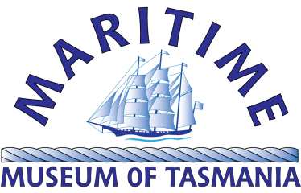
Monthly Lunchtime Talks Program
Tuesday, 3 September 2019

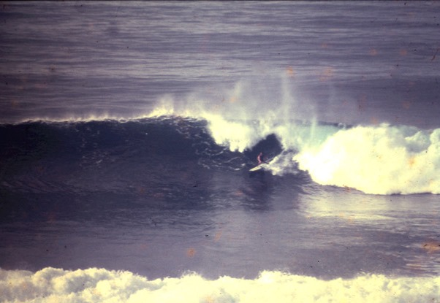
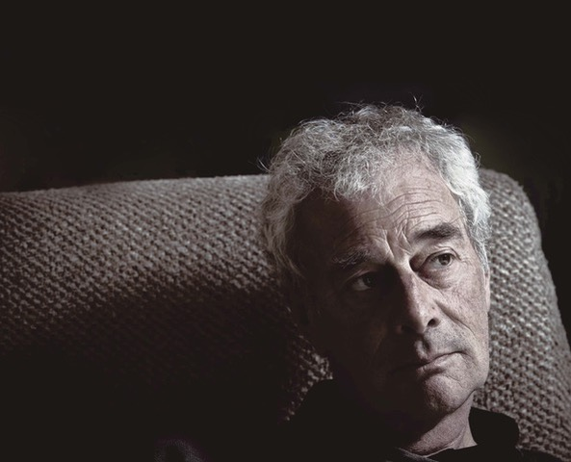
Surfing in Tasmania
Presented by Michael Lawrence, Surfing Legend
Surfing is the ancient practice of Polynesians and was first recorded by Joseph Banks in Tahiti in 1769. He was aboard HMS Endeavour as part of Cook’s first voyage of exploration to the Pacific. Banks' description of surf-riding is rich in detail and typical of his scientific approach. Cook was to record canoe surfing on his return to Tahiti in 1777, and the third voyage recorded the first European account of Hawaiian surf-riding. They rode boards adzed from trees and may have been doing so centuries before Banks observed them. Surfing most likely began in Tahiti before spreading to Hawaii and, in the last 100 years, throughout the world.
It was introduced to Australia by Duke Kanhanamoku at Freshwater Beach, Sydney in 1915. Surprisingly, the first commercial surfboard in Australia was made in the 1920's by Launceston firm Risby Brothers. Modern malibu surfboards arrived in Australia in 1954 as part of an exhibition at the 1956 Melbourne Olympics. The film Gidget, released not long after, resulted in the birth of modern day surfing. The first malibu boards arrived in Tasmania around 1957 and a small following began around the state. By the mid 1960's, the sport gained popularity but was mainly the realm of boys in their late teens. Now the sport is the chosen lifestyle of around five thousand Tasmanians, male and female spanning three generations. Dara Penfold was 1999 junior world champion and the recent Red Bull Cape Fear contest held at Shipstern Bluff, saw 10 Tasmanians in a field of 20. Surfing is a microcosm of modern society and is suffering from population overload. Once deserted spots now have crowds exceeding 200 surfers, even on remote tropical islands. Surf rage is becoming common. The irony is that wave pools with perfect man made waves are springing up in suburbs around the world as natural waves are being loved to death. In little over 100 years the ancient Polynesian art of surfing has reached the crossroad. Nature or the machine?
Michael Lawrence is a filmmaker, writer and wilderness guide. Born in Hobart in 1947, he has always had a strong connection to the ocean. He was State backstroke champion in 1963, State surfing champion in 1966/67. His travels have included Hawaii, California, Mexico, New Zealand and the Indonesian archipelago. In 1994, he was involved in the ‘discovery’ of Shipstern Bluff as a surfing location. In 2007, he took up sea kayaking, exploring and filming the Southwest wilderness. As a filmmaker, Michael has produced over 100 documentaries, as a writer he has written articles for national and international surf magazines and a book on the history of Tasmanian surfing 'Surfing on the Inside'. For the past four years, he has been a guide at a Port Davey wilderness camp.
Time: 12.00-1.00pm, Tuesday 3 September 2019
Place: Royal Society Room, Tasmanian Museum and Art Gallery, Customs House, 19 Davey St entrance.
Phone the Maritime Museum on 6234 1427 for more details or email john.wadsley@maritimetas.org

